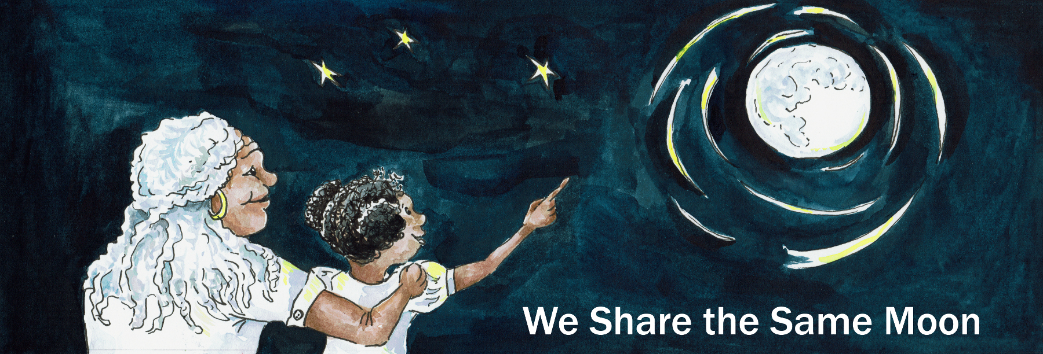
Suggested Age Range: 7 - 8 years; 8 - 9 years; 9 - 10 years; 10 - 11 years
UK Curriculum; Key Stage Two (Lower) Key Stage Two (Upper)
Suggested UK Year Group: Year Three, Year Six
UK Primary Curriculum Link: Light
Science Subjects: The Sun; Eclipses
Science Question: Why do we have Eclipses?
Suggested Science Activity: Eclipses
Children with SEND: Use to boost comprehension of science vocabulary
EAL children: Intermediate Level
Country of Origin: Mexico
Source: Fiesta Feminista by Mary-Joan Gerson

Long ago, in the time before there was a country called Mexico, the people who lived in that land were called the Maya. They lived high in the mountains and deep in the rainforest that spread across the land, we now call Mexico.

And, in the edge of the rainforest, there was a village, and in that village, there was a house, And in that house, there lived a family. A man and a woman and two children, an older girl and a younger boy. And the two children would play together running in and out of their house, their village, and their forest.

And when they wanted to hide from the burning hot sun, they would escape into the dappled shade of the forest and there they would sit under a tree and dabble their feet in a cool, cool stream.

But, as the sister grew older, she grew tired of their childhood games. She would wander off by herself to find somewhere to sit and play with her long black hair. She would comb it over and over and over until it shone. But, she left her bother all alone.
And so it was on one hot day, the brother could not find his sister anywhere.
Where could she be? He searched the whole village but there was no sign of her.
And it was so hot! All he wanted was a friend to sit with him, by the cool, cool stream.
But his sister was nowhere to be seen. She had hidden from him once again so completely that though he tried long and hard to find her - he could not!
He stood by himself in the hot, hot Sun and he felt the heat of the sun burn his skin and the sweat trickle down his back and arms.

And as he stood there he thought:

Enough is enough! I will teach her to hide from me!
I will teach her to love her long black hair - more than she does me!
A lesson she won’t forget in a hurry!
Hah! And as for you Sun, that burns my skin so carelessly.
I will teach you too - not to ignore me!

That night, whilst his sister was asleep, her brother watched her from his own mat on the floor. And, as soon as her breathing slowed, he pulled back the sheet and silently got to his feet. He tiptoed across to his sister, who was by now fast asleep, with her long black hair strewn across the mat and onto the floor. And as he stood there looking down at her, with his knife held tight in his hand …

Very quietly, taking care not to wake her, he bent down and began to cut off her hair! He pulled her hair taut, very, very carefully and he cut it strand by strand, as quickly and as gently as he could. Done!
And in his hand was a huge bundle of long black hair - longer than you have ever seen!

Now, for the second part of his plan! He crept out of the hut and into the forest. And he began to braid the hair into a net, that grew bigger and bigger and bigger! Big enough it seemed to catch the Sun!

Which was the third part of his plan! He attached the net to a long, long rope which he coiled around his waist. He crept through the forest until he reached a clearing, where he could see the sky above, and the faint gold glimmer of the sun as it began to rise. He uncoiled the rope and spun the net into the air like a lasso, whoo, whoo, whoo! And it whirled around and around until it came down and captured the Sun!

The Sun tried to pull free, but the boy, though young, was too strong.
The boy pulled and pulled and pulled on the rope that connected the net and held the Sun tight in his trap. The Sun was forced to the ground and hidden from view, under the mass of netted hair. His plan had worked!

Meanwhile back home, the villagers had began to rise with the Sun.
Then, all of a sudden, the Sun disappeared!
The sky grew dark, eerily dark,
The birds stopped singing, and all was deadly quiet.
Then the dogs began to howl, and the sound of their howling was somehow worse than the silence. People ran out of their huts. There was confusion everywhere!
What has has happened to the Sun? No-body knew.
Nobody knew what to do! And the air was filled with sounds of fear.

The girl woke up and heard the noise. She ran outside and saw for herself what was wrong. The Sun, the Sun had gone!
And then she realised too - that something else had gone! Her hair!
Could these two things be connected?
Who could have done this? And then she thought - MY brother!
She looked around for her brother. There he was, sat under a tree, looking very innocent, as only younger brothers can.
“What have you done?” “Me, nothing!"
“Yes you have!” “I haven’t!”
“Yes, you have!” “I haven’t!”
You have! What have you done?
“I cut off your beautiful hair that you love so much and made a net to capture the Sun!”. “And there is nothing you can do to set it free!”
Well, his big sister was not going to stay and listen!
She ran into the forest, looking for some way to set free the Sun.
She saw a Rabbit hopping about in the darkness.

“Rabbit, Rabbit, will you help me, to see the Sun free?”
“Me!” said the Rabbit “What can I do?”
“I am far to small to help!”

She ran on into the forest, looking for anyone who could help her set free the Sun.
She saw a deer leaping frantically through the trees.

“Deer, Deer, will you help me, to set the Sun free?”
“Me! said the Deer “What can I do?” “ I am far too scared to help!”

She ran on, but there was no-one left to help.
They were far too scared of the strange dark to listen to her pleas.
But, then she heard a tiny voice.

"I will!”
And there, nestled amongst the leaves at the foot of a tree, was a Mole, a little Mole. With his silky long hair that swept across his tiny body and onto the leaves, making them rustle gently.

“You? But what can you do?”
“Well, I don’t know but I can try!”

She picked him up and stroked his long, long fur. She curled her arms carefully around him - and then together they ran on and on and on!

They ran to the very edge of the forest and there on the ground was a huge glowing ball of heat and light - the Sun! Tied up in a huge net of hair!

“My brother was telling the truth! He has captured the Sun!”
“We must set it free! But how? What can we do?”

“Put me down!” ordered the Mole.

And she did. He ran towards the net, biting, biting, biting at the tangled mess of hair. Ouch! It hurt! The Sun was so hurt, it burnt his mouth and his teeth and his beautiful long fur! But still he carried on, biting, biting, biting the hair, undoing the trap - until at last the Sun was free!

The Sun rose up into the sky - whoosh - and its golden glow filled the air!
But, as for the poor little Mole, all his long fur had gone, burnt by the Sun.
The Sun’s golden rays came down to Earth and gently stroked his skin.

“From now on”, said the Sun, “Your fur will be very short as a mark of the price you paid to set me free! But, in return, your hands will be big, so you can dig yourself out of danger. And keep yourself free!”

And as the girl watched, the Mole’s hands grew larger and larger and larger.
The Mole began to dig at the Earth so fast that soon he had disappeared from her sight. She never saw him again. But she did not forget.

And THAT is why, every time the Moon sails through the sky and passes between the Earth and Sun, so that the Sun is hidden from our view by the Moon, what we call a Solar Eclipse, the Maya people they stop and remember the Mole, who had set the Sun free - the very first time.

Or at least that was what I was told!

Retold by Cassandra Wye June 2017. Reprinted here with kind permission from The Vanishing Sun https://www.lpi.usra.edu/education/explore/eclipse

